OLW NEWS 2020
Tel: 9460 6684
Email: principal@olwkingsbury.catholic.edu.au
Issue: 3 Date: Monday February 17 2020

Dear Parents & Families,
Last week our school community was saddened by the passing of Alberto Gamos – father of current student Felicity (Year 4/5) and past student Jared. I would ask that you keep the Gamos family in your thoughts and prayers during this difficult time.
YEAR 12 RESULTS
Last week we were pleased to be informed that former student Ian Chen was one of only 37 students across Victoria who achieved a perfect ATAR ranking of 99.95 this year. We have also been pleased to hear of the excellent performances of many former OLW students studying VCE in 2019, with all now headed for their preferred University course or further study.
EDUCATION BOARD
Our Education Board is an important body who support the work of the school and provide advice to the Principal and Parish Priest on school matters. At the end of 2019 two members concluded their time therefore, we are seeking 2 new members for the Board for a period of tenure of up to 3 years.
If there are more than 2 nominations, then this may need to go to a vote of the school community.
To give you an idea of the work and responsibilities of the Board, I have included some information in today’s newsletter. Some of the main purposes and responsibilities of the Board are:
- to act as a forum for discussion on matters concerning education;
- to provide a link between the parish priest, principal, teachers and parishioners in relation to the provision of Catholic education in the parish community;
- to promote community development;
- to promote the Catholic ethos of the school and to support the Religious Education programs;
- to provide advice on school policies when required, to plan for the future of the parish primary school and its ability to accommodate future enrolments.
Some of the key qualities and skills for members of boards are:
  - Commitment to Catholic education in the parish and school
  - Commitment to the vision and mission of the parish and school
  - An understanding of the role of parish priest, principal and board members
  - Willingness to ask questions and seek clarification
  - Ability to think strategically
  - Willingness to support the contributions of other board members
  - Capacity to listen in an active and meaningful way
  - Willingness to work co-operatively with others
  - Commitment to maintaining confidentiality at all times.
Our Meeting dates for 2019 are: March 18, May 13, June 10, August 5, September 9, and November 25.
If you are interested in becoming a Board member, please send in a letter of interest stating that you wish to apply for a position on the Ed Board to the school office by Friday March 6.
PARENT HELPER REFRESHER TRAINING
Thank you to all the parents who attended the Parent Helper Refresher Training this afternoon. As part of their training, all parent helpers received an updated copy of our Child Safe Policy and Parent Code of Conduct.
NEW PARENT HELPER TRAINING
All new parents who wish to assist in our Literacy Sessions in 2020 are required to attend two training sessions. The first session, focusing on assisting children learning to Read and will be held on Monday February 24 from 2.00 – 3.20pm. The second session will focus on assisting children with learning to Write and will be held on Monday March 2 from 2.00 – 3.30pm. These sessions are for new parent helpers to the school who may wish to assist in the classroom in 2020.
As part of these sessions, we will also work with each parent to complete the necessary documentation to meet the Child Safe Standards. This will ensure that all our volunteers meet the standards under this new Ministerial Order. Please complete the response form attached to today’s newsletter if you wish to be a New Parent Helper in 2020.
If Parents are unable to attend the Refresher or New Parent Training sessions in Term 1, a second round of sessions may be repeated later in Term 1 or Term 2 if numbers allow.
BEGINNING OF YEAR MASS
Our Beginning of Year Mass will be held this Tuesday, February 18, at 10.00am. Everyone is most welcome!
ATHLETICS TRIALS DAY
As part of our selection process for our District Athletics Team we are holding an Athletics Trials day for Years 3 – 6 this Friday, February 21. Students will need to wear their sports uniform this Friday.
Enjoy the week!
Kevin Burke

WORD OF THE WEEK
Congratulations to everyone who found out that peculiar means different to what is normal or expected; strange’ or ‘particular; special’.
Our word of the week for this week is:
SANGUINE
Find out it’s meaning and origin and see if you can add this word to your vocabulary over the next week!

OLW COMMONWEALTH BANK SCHOOL BANKING
Just a reminder that the school banking will continue on Wednesdays during the school terms. For new families you can go to the bank or online to register for your child to have an OLW school banking account.

RELIGIOUS EDUCATION NEWS
SACRAMENTAL DATES FOR 2020
The dates for the Sacraments have been set for 2020. They are as follows:
First Eucharist (Year 3) - Commitment Mass Sunday May 3rd at 10:00am
The Sacrament of First Eucharist Sunday 31st May at 11:30am
Confirmation (Year 6) - Commitment Mass Sunday June 21st 10:00am
The Sacrament of Confirmation Thursday July 23rd at 5:00pm
Reconciliation (Year 2) - Commitment Mass Sunday 18th October 10:00am Sacrament of Reconciliation Tuesday 7th November 7:00pm

PARENTS & FRIENDS ASSOCIATION NEWS

FEBRUARY SILVER COIN CHALLENGE

To start the year off we will be running our Silver Coin Classroom fundraising challenge in the month of February. Bring to school all the 5, 10, 20 and 50 cent pieces you have been saving or collecting.
The class who raises the most money will receive the perpetual trophy and a free hot chip lunch. Who will be the winning classroom this year?

ICY POLES
Icy poles are sold each Tuesday & Thursday. Icy poles are limited to 2 per person and are 50 cents each

NEW PARENT HELPER TRAINING

I _________________________ will be
attending the New Parent Helper
Program on Monday February 24 & March
2.
Eldest child’s name _________________
Eldest child’s grade _________________
Contact No: ________________________

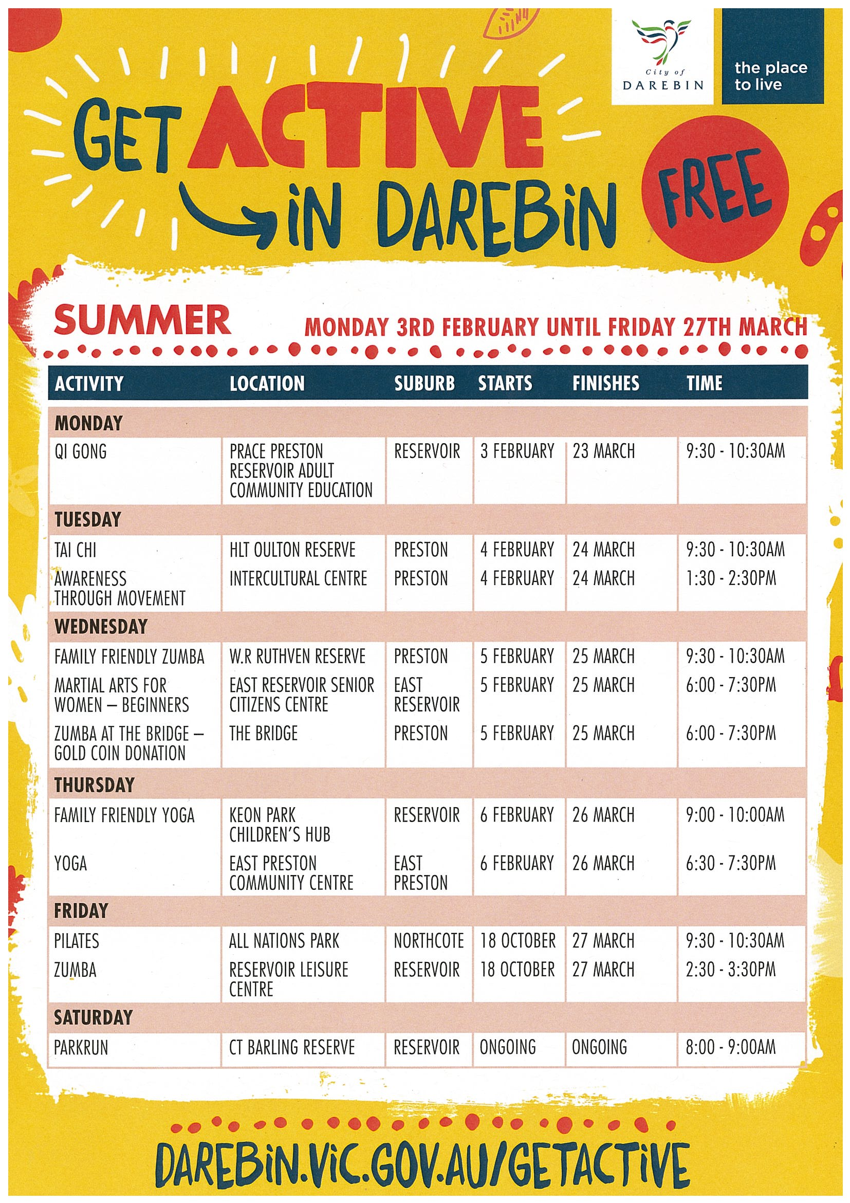

Parish of Our Lady of the Way Kingsbury
Presbytery: 13 Green Ave, Kingsbury, 3083

Parish Priest: Fr Terry Bergin Tel: 9462 1221 School Tel: 9460 6684
Email: terrybergin1@bigpond.com

 | Parish Website: OLW Kingsbury
 | Mass Timetable
 | Saturday – Vigil Mass:  Sunday:  Weekdays:  Sacrament of Reconciliation:  Rosary Monday to Saturday:  Divine Mercy Chaplet  Exposition of the Blessed Sacrament: | 6.00PM  8.00AM and 10.00AM  10.00AM  Saturday from 5.15 to 5.45PM  9.30AM  After Mass Daily  Friday from 9.00 to 9.30AM
 | Baptisms and Marriages by appointment: Please ring 9462 1221

Entrance Antiphon: Be my protector, O God, a mighty stronghold to save me.
For you are my rock, my stronghold! Lead me, guide me, for the sake of your name.

Communion:
God so loved the world that he gave his Only Begotten Son, so that all who believe in him may not perish, but may have eternal life.
.
Readers for Sunday Mass
16th Feb 6pm E Almeida 8am B Bowlen 10am M Leonard
23rd Feb 6pm J Wild 8am M Browne 10am I Lowe

Extraordinary Ministers of Holy Communion
16th Feb 6pm K Zanini & Volunteer required 10am B Hayes & Volunteer required
23rd Feb 6pm E Gleeson & Volunteer required 10am D Austin & Volunteer required

OLW Church Cleaning Roster

29th Feb Professional Cleaners
14th Mar McGoon, T McGree and J O’Mahony

OLW Sacristy Linen Laundering Roster
16th Feb Lan
23rd Feb Elspeth Garbellotto

2nd Feb Church Account $1,149.00
Presbytery Account $831.50

Sick - 6 pm. Fr Theo Rush a friend of Frank & Maureen Williams is sick in hospital.

Movie – Ride Like a Girl - $12.00 per person and lunch is included. Please sign the sheet in the foyer if interested.

To all parishioners: We are hoping you will give us your favourite recipes. We are putting together a recipe book for Mother’s day. I challenge the men for their recipes, it may be mums or your wife. Get to it now!

Parish Lunch: Last Wednesday of the Month. This month February date for lunch is Wednesday 26th at 12.00 at the Bundoora Hotel. Please put your name on the list in the Foyer.

Ash Wednesday
Wednesday 26th February. Mass times are 10 am and 7pm Wednesday. Ashes will be distributed at both Masses.

Classical guitar music Afternoon Tea – Sunday 16th Feb
We are in need of some volunteers to help with the organising and catering so as to make this an unforgettable afternoon for everyone. Please contact Pia Matthews on 0404 135 249 in order to make this happen!
Many Thanks - Pia

Ageing and Awakening to God’s surprises.
Please take a brochure from the foyer table. Our later years hole amazing possibilities.
Do you find yourself thinking about life: eg How am I coping with change: Can I let go?
Then come along to OLW to church foyer for 6 sessions: 10.30am, 12.30pm this year beginning
April 17th
May: 1st, 15^{th ,} 29th
June: 12th and 26th
Sr Kerin Caldwell is our inspired leader for these sessions. Her resume is written in the brochure.

First Friday of Each month – Pizza night for everyone 7-9 pm – a meet and greet with other parishioners

******

Some days I amaze myself
Other days, I look for my phone while I’m holding it.

ASPIRE FINANCIAL & RETIREMENT PLANNING PTY LTD
Specialist in Taxation, Superannuation, Retirement Planning, Centrelink issues and Estate Planning. Contact Mike or Gavin Jolley on 9466 8777
ASTRO GRAPHICS
For all your Designing & Printing needs. Contact Sue & Chris Schembri on 9350 7033
TONY’S IT EXPERTS
Need a computer expert? Contact Tony for a free quotation on 0423 694 938
A & G HOME AND OFFICE FURNITURE REMOVALS. Call 9464 3931
BUNDOORA DRY CLEANERS (Polaris). Call 0469 784 285

